
FACULTY OF TECHNOLOGY AND ENGINEERING
DEVANG PATEL INSTITUTE OF ADVANCE TECHNOLOGY
AND RESEARCH

DEPARTMENT OF COMPUTER ENGINEERING

A.Y 2026 – 27 Semester – 3

LAB MANUAL

CSUC201 Fundamentals of Data Structures and Algorithms

Practical 10: Hash Tables: Linear Probing, Chaining, and
Double Hashing
Practical Aim
To implement hash tables using different collision handling strategies and develop the ability to reason about why collisions occur, how different strategies resolve them, and what trade-offs each approach involves.
Problem 1
A small parking lot has exactly 10 numbered slots (0 to 9). When a vehicle arrives, its registration number is used to assign it a slot by taking the last digit of the number. If that slot is already taken, the vehicle moves to the next available slot in order, wrapping around if necessary. Given a sequence of vehicle registrations, assign each to a slot using this rule and display the final state of all ten slots.
Describe what your solution does when it encounters an already occupied slot. What happens when the parking lot is nearly full and many vehicles keep landing on the same slot? Can you think of a situation where your solution might loop indefinitely?

For Code:

Output:
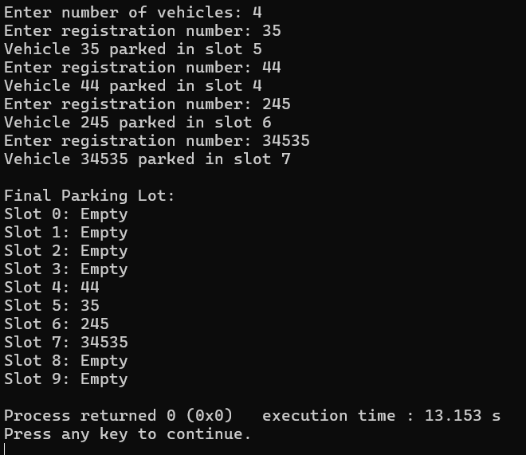

Problem 2
A library uses a system with 10 shelves numbered 0 to 9. Each book's code is used to decide which shelf it belongs to by taking the code modulo 10. Unlike the parking lot, each shelf can hold multiple books stacked together — when two books map to the same shelf, they are simply added to that shelf's stack. Given a sequence of book codes, place each on the correct shelf and display the final contents of all shelves.
Describe how your solution handles two books that map to the same shelf. What happens to search time on a shelf as more and more books pile onto it? Can you think of what would cause all books to end up on the same shelf?
For Code:

Output:
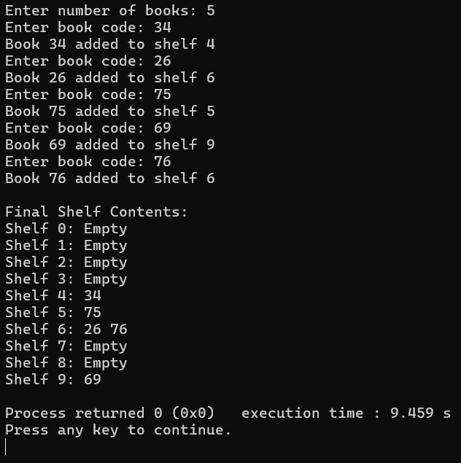

Problem 3
A university assigns student IDs to storage slots using a two-step rule. The first rule determines the initial slot. If that slot is taken, instead of simply moving one slot forward, a second rule based on the ID itself determines how many slots to jump. This means different IDs that collide will probe different sequences of slots, spreading them more evenly. Given a sequence of student IDs, assign each to a slot using both rules and display the final state of the table.

Describe how your solution decides how many slots to jump when a collision occurs. What is the risk if the jump size happens to be a factor of the table size? How does this strategy differ from Problem 10.1 in how it spreads collisions?

For Code:

Output:
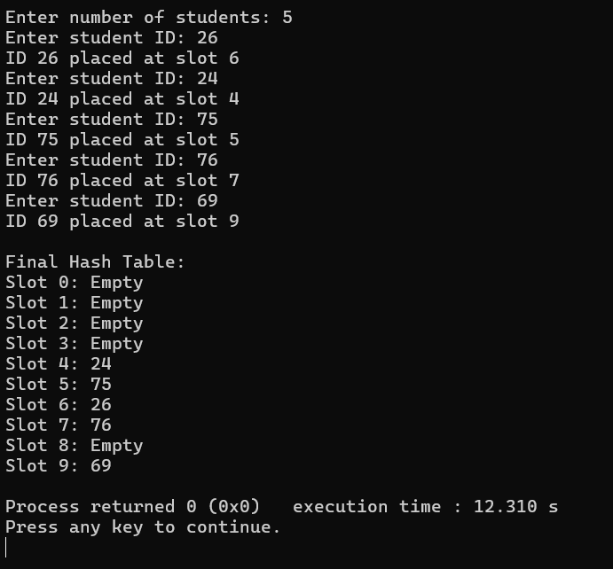
Outcome/Conclusion:
These three practicals helped in understanding hash tables and different collision handling techniques. We implemented linear probing, chaining, and double hashing, and learned how collisions are resolved and how the choice of strategy affects the distribution and efficiency of stored data.

Key Questions / Analysis / Interpretation to be Evaluated During/After Implementation
- [Problem 1] A circular array is one way to reuse freed slots without shifting all elements.
Without implementing it, explain what change would need to be made to your front and
rear pointer logic to make the array behave circularly, and what new condition would
indicate a full array.
Ans:- The front and rear pointers should wrap around to the beginning when they reach the end of the array, using modulo logic. The array is full when (rear + 1) % size == front.

- [Problem 2] Your linked list stack has no fixed capacity limit. But in practice, can it still
run out of space? What determines the actual limit, and why is that limit invisible in your
code?
Ans:- Yes, a linked list stack can still run out of space. Its limit depends on the available system memory (heap). This limit is not fixed in the code because nodes are created dynamically until memory is exhausted.

- [Problem 3] operator precedence determines the order in which operators are placed
into the output. Without tracing any expression, explain what would go wrong in your
output if your solution treated all operators as having equal precedence.
Ans:- If all operators have equal precedence, operators would be processed in the wrong order. For example, multiplication might not be performed before addition, resulting in an incorrect postfix expression and wrong final result.

